DRC 2019 STRATEGY PLAN-

1ST DRAFT-

Questions to Consider-

* How will we detect the line?
  + Utilise Open CV to detect the colours of the lines
* How will we view the lines?
  + Use a perspective transformation to get a bird’s eye view of the track to get a better estimation of what is in front of us
* Once both lines are detected where will we position the car?
  + In the centre of the track while the car is moving in a straight line
  + Closer to the outer edge of the track moving along the ‘racing line’ while turning a corner
* How do we get the car to follow the track?
  + Estimate 3 points in front of the droid and have the droid align a straight line through them
* What is the best path to take around the track?
  + In the real world , the racing line. But we aren’t professional racers
  + For us, taking the centre of straight paths and then moving to the edge to begin to follow the ‘racing line’ on corners
* How fast should we go?
  + Fast on straight bits (100%)
  + Slow on corners (60%)
* How will avoid obstacles ?
  + Detect where the object is relative to the lines
  + Take its distance to both edges and determine which one it is closer too
  + Depending on which line the obstacle is closer to, activate a different algorithm to move around.
    - ie. if obstacle is closer to the left, use the “Move around from Right” algorithm
* What are the limitations to our droid?
  + Distance our camera can see in front of it
  + Speed of our motor
  + Frame rate and processing rate of our camera
  + Mass
* Are we going to use Matlab?
  + Yes, to print “hello world”

Overall Strategy to Follow Line-

* When the path is straight, follow the centre point of the two edges
  + To do so, estimate 3 points in front of the droid consistently, and have the car always try to align itself to those 3 points
* When one of the lines becomes shorter, this means that it is the inside edge of a curve
* Move car to the outer edge of the curve to give the greatest opportunity for speed
  + Station a point on the edge of the inside curved line
  + Have the droid maintain a constant distance to the point
  + Align a horizontal line along the camera’s vision to the point
* GOTTA GO FAST

Useful Resources to Explain Strategy-

<https://www.youtube.com/watch?v=xhI71ZdSh6k-> Where I got inspiration for the camera and line following

<https://www.youtube.com/watch?v=3HwnJ1VkWA4>

Racing Line-

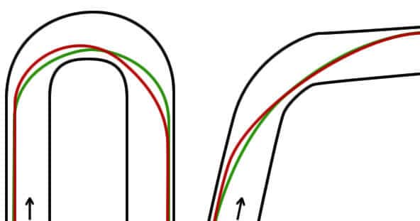

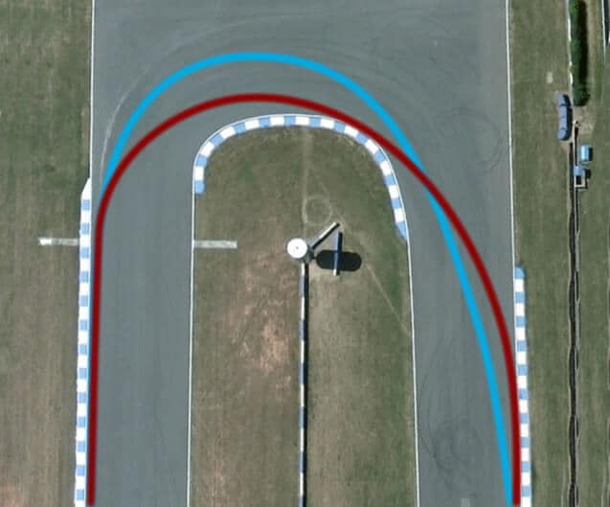

Camera View-

